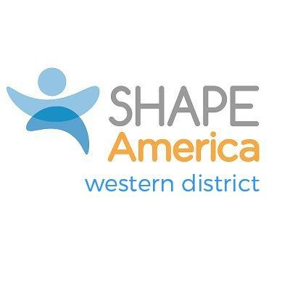
WESTERN DISTRICT SERVICE AWARD
Nominations by September 15
Applications by October 15
Return to District Awards Chair: See SHAPE America Western District webpage

Description:
The Western District Service Award recognizes an individual or organization making a significant contribution to the Western District. This award shall be given when uniquely deserved and is therefore not necessarily an annual event and multiple awards may be given in any year. Any individual or organization is eligible to receive this award, in that SHAPE America membership is not a prerequisite, though exceptional leadership and/or service should be exhibited.

- SHAPE America Membership: Not required for this award

- Include written examples of the outstanding service, special projects, programs, research conducted by the organization or individual that has promoted the mission of SHAPE America in the Western District.

